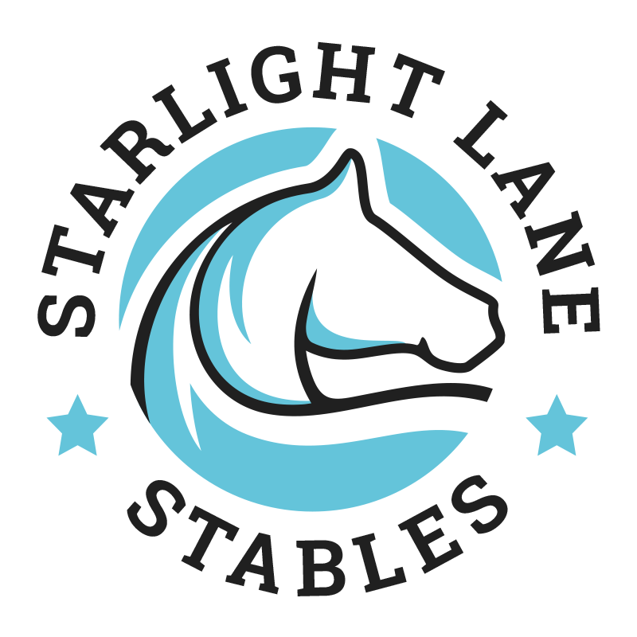
is proud to present the
Starlight Lane Training Show

Saturday 10 September 2022
CATERING AVAILABLE • ROSETTES & SPONSORED PRIZES
MORE INFO ON THIS EVENT HERE

Entries Close | 8pm Thursday 8 September 2022  Entries available on the day for an extra R20 per class | Start Time | 08:00:00
Enquiries | Chloe: 067 740 6370 or info@starlightlane.co.za
Banking Details | Bank: Capitec  Branch Code: 470010  Account No: 1351606970  Reference: SL show + your name | Entries to: | Email: info@starlightlane.co.za  (Include payment confirmation)
Dress code: | Yard shirts/golf shirts/jodhpur boots/shoes with small heel, hard hats

JUMPING CLASSES :
R115.00 (classes 1 – 3)
R135.00 (classes 4 – 6)
Class 6 - cost is per pair!
Late entries & entries on the day if available: Additional R20 per class

JUMPING:
CLASS | HEIGHT | DESCRIPTION | CLASS | HEIGHT | DESCRIPTION
1 | - | Pole on the ground | 2 | 30cm | Round Robin (one round)
3 | 50cm | Jump for Joy (one round) | 4 | 60cm | Competition (two rounds)
5 | 70cm | Welcome Stakes (two rounds) | 6 | 70cm | Cable Stitch (pairs)

ENTRY FORM
EFT PAYMENTS ONLY PLEASE – ADD R50 TO TOTAL FOR CASH DEPOSITS!
WE UNFORTUNATELY CANNOT ACCEPT ENTRIES WITHOUT PROOF OF PAYMENT
Please save this form to your desktop, open in Word, fill in, re-save and email back
PLEASE DO NOT PRINT & SCAN THIS FORM
Email: info@starlightlane.co.za (Include payment confirmation)
Entries unaccompanied by the correct entry fee will not be accepted.
The organizers reserve the right to cancel and/or combine classes should they deem it necessary.

CLASS | HORSE | RIDER |  | FEE
 |  | TOTAL
Name |  |  | Email:
Address
Cell
I undertake not to bring any horse to this show which has an infectious disease, whether notifiable or not, or which horse I could reasonably be expected to know has an infectious disease or may spread an infectious disease.

INDEMNITY: Starlight Lane Stables and/or their employees will not be held responsible for any damage, theft, injury or death sustained by riders, horses/ponies or any member of the public and/or their property whatsoever whilst on the premises.
Signature

TERMS & CONDITIONS
- Competitors are required to be correctly dressed.
- Current SAEF & FEI show jumping rules will apply to this show.
- The organizers reserve the right to cancel and/or alter the program should they deem it necessary.
- Entries will be on a first come, first served basis. When depositing money, use riders name as payment reference and include POP with entry. ADD R50 TO TOTAL FOR CASH DEPOSITS!
No entries will be deemed as accepted unless we have received your POP.
- Neither Starlight Lane, their officials or representatives shall in any way be held responsible for any loss, damage, theft or injury sustained by horses, riders, appointed officials, the public or their property at the show, caused by or resulting from the show.
PLEASE NO DOGS!!
Paramedics will be on site.

